SUPER STORE DATA REPORT & SQL QUERIES

# **The domain of the Project:**

Structured Query Language (SQL), Power BI

# 

# **Under the guidance of**

Ms. Siddhika Shah (POWER BI & SQL)

# **BY**

Ms. Jhansi Singavarapu (B.Tech Final Year CSE(IOT))

# Period of the project

# October 2024 to January 2025



SURE TRUST

PUTTAPARTHI, ANDHRA PRADESH

**Declaration**

**The project titled “*super store data report & SQL queries*” has been mentored by *Ms. Siddhika Shah* organised by SURE Trust, from October 2024 to January 2025, for the benefit of the educated unemployed rural youth for gaining hands-on experience in working on industry relevant projects that would take them closer to the prospective employer. I declare that to the best of my knowledge the members of the team mentioned below, have worked on it successfully and enhanced their practical knowledge in the domain.**

**Name Signature**

**Ms. Jhansi Singavarapu**



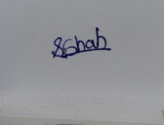**Mentor Signature**

**Ms. siddhika Shah (power bi & sql )**

**Prof. Radhakumari**

**Executive Director & Founder**

**SURE Trust**

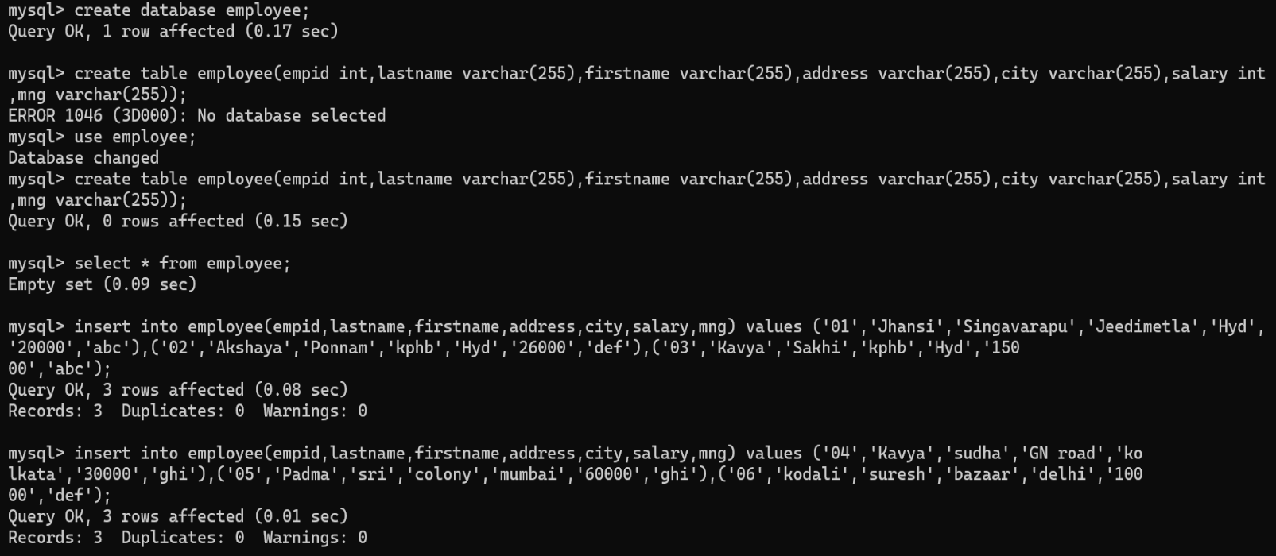Create a database:

Create table:

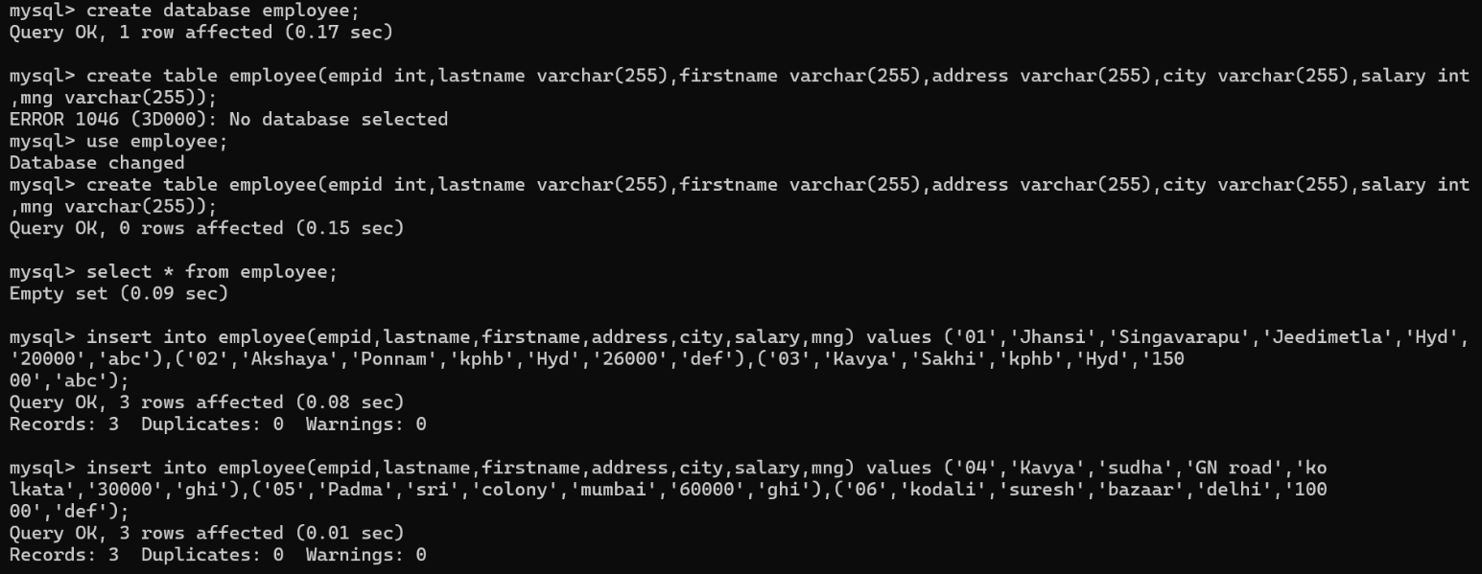

Insert values:

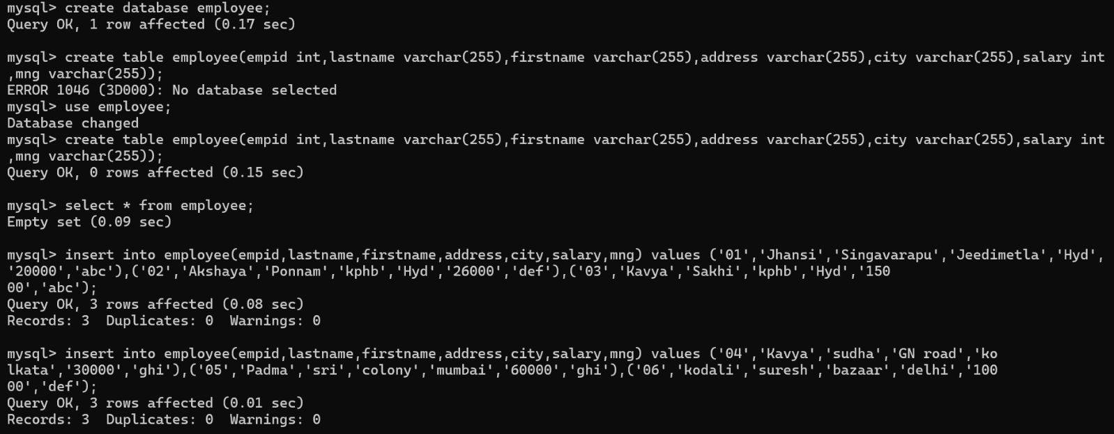

Display record:

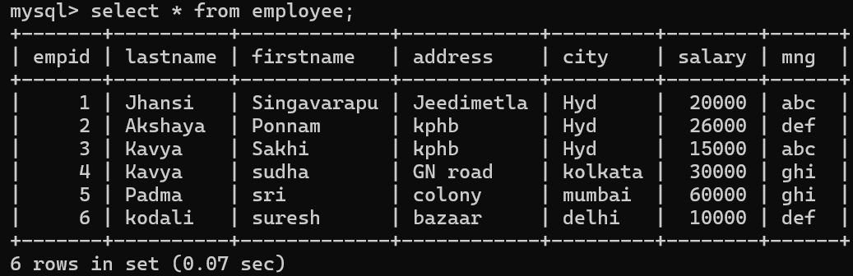

Is null and Not Null:

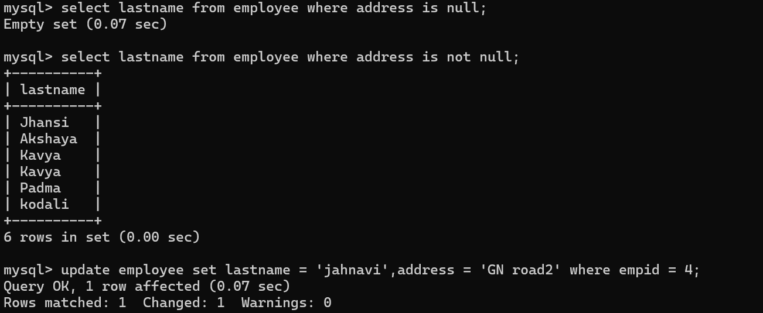

Update the values: 

To display limited values:

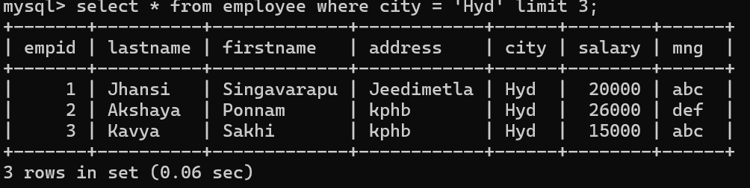

AGGREGATE FUNCTIONS:

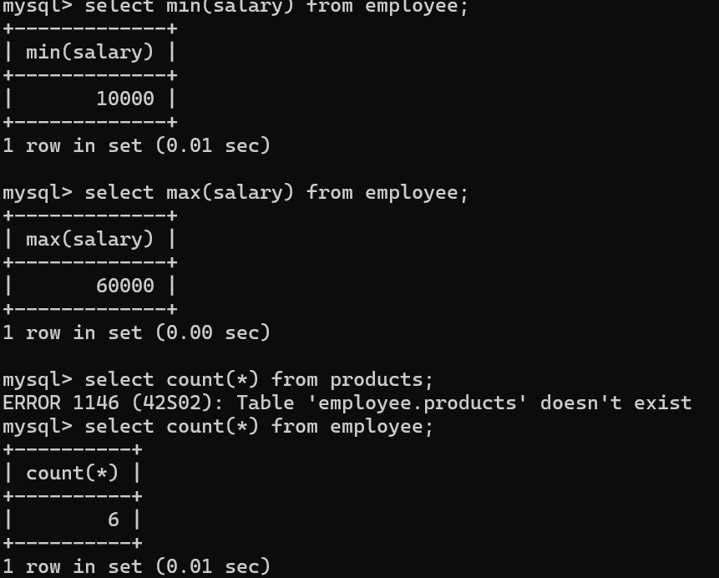

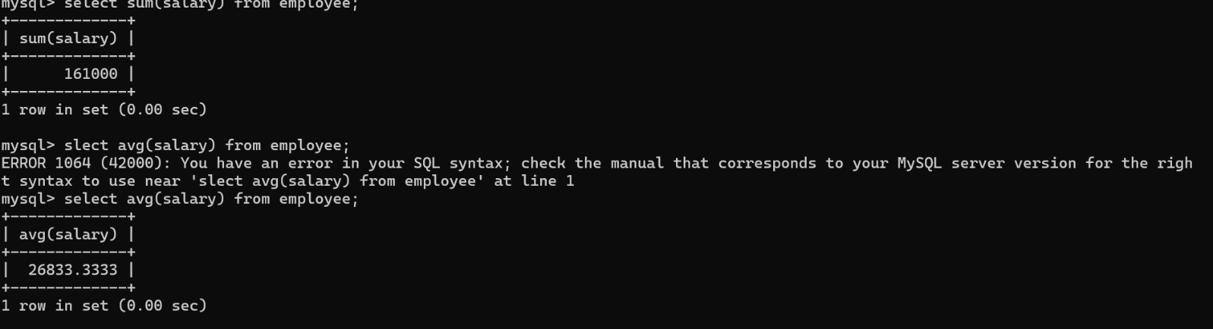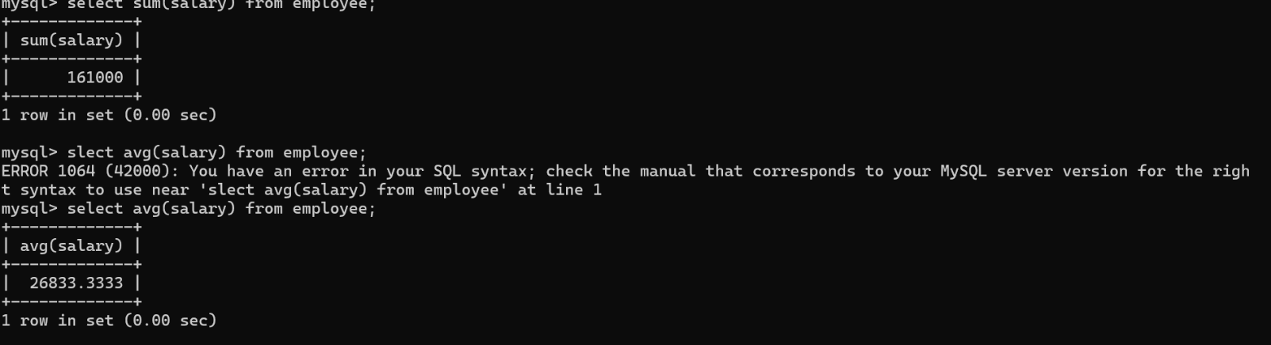

JOINS:

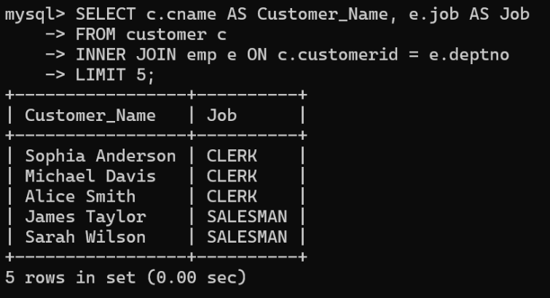Table1 Table 2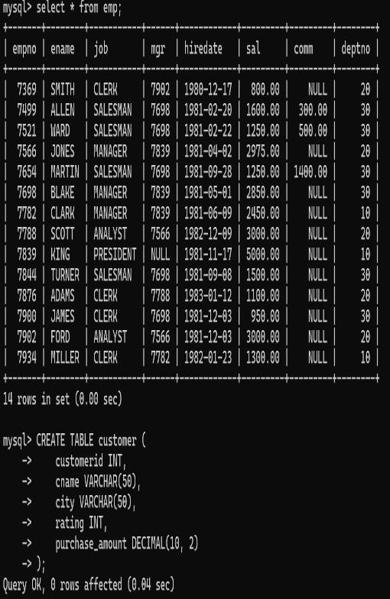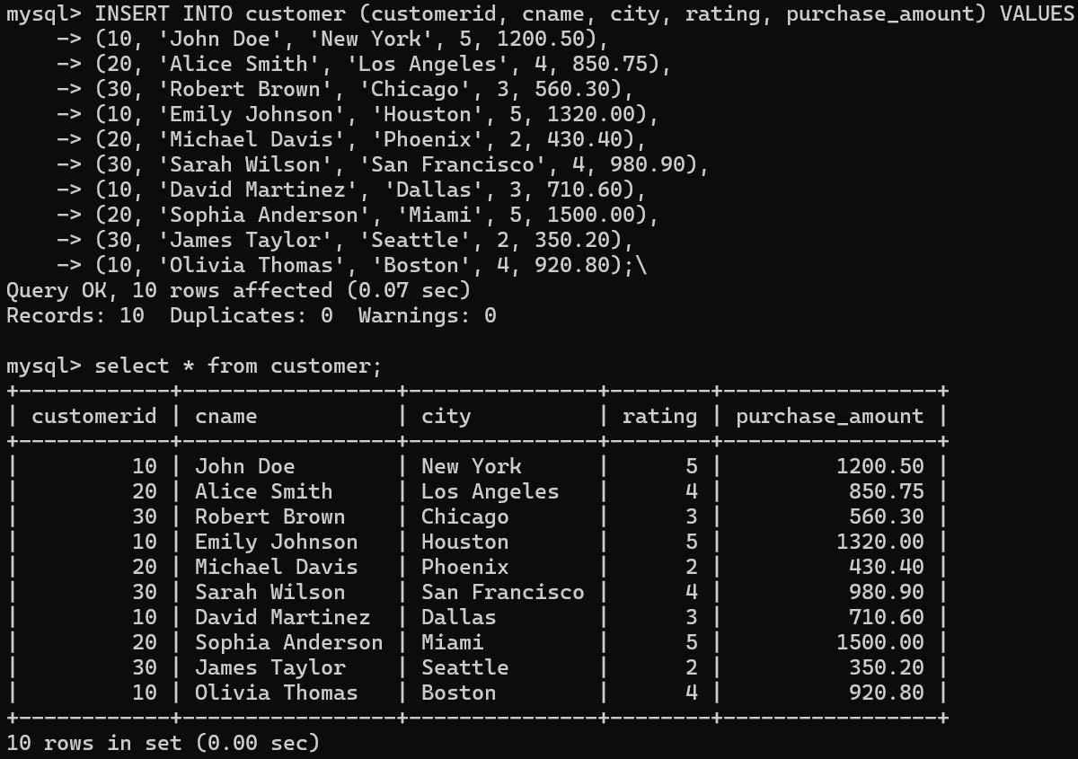

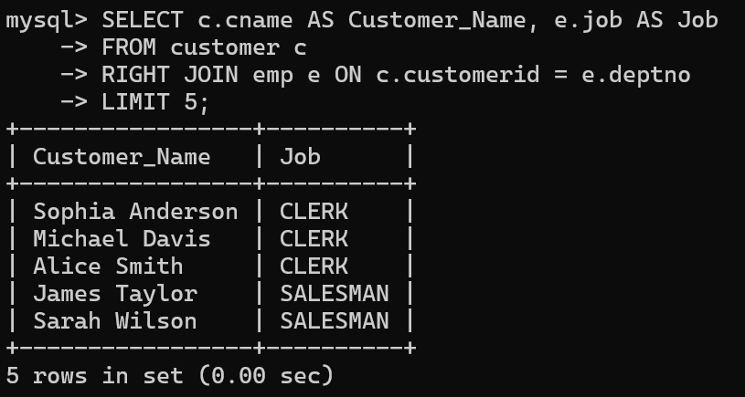

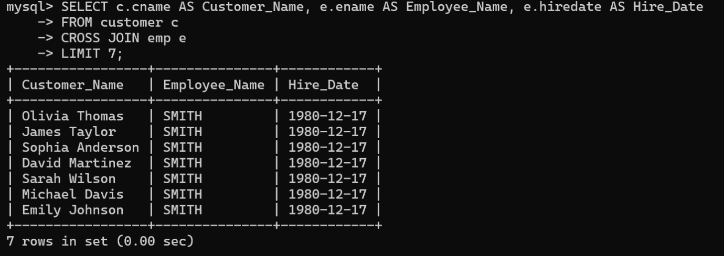

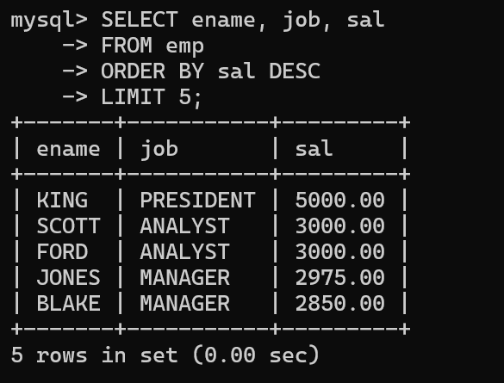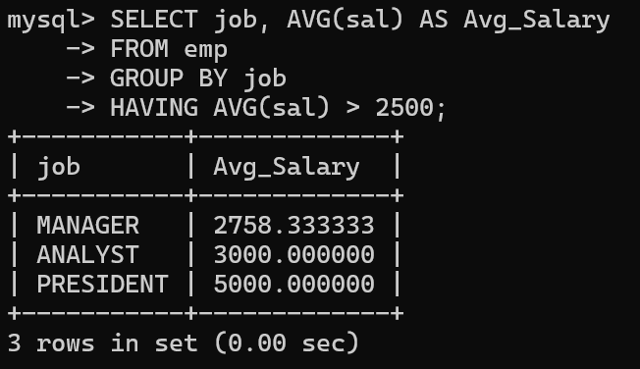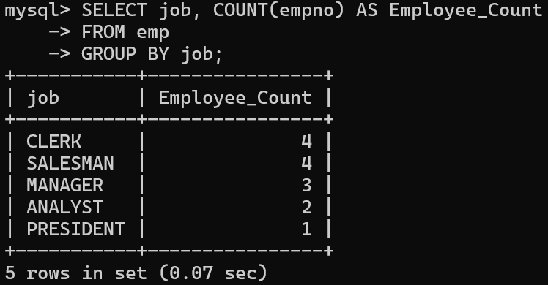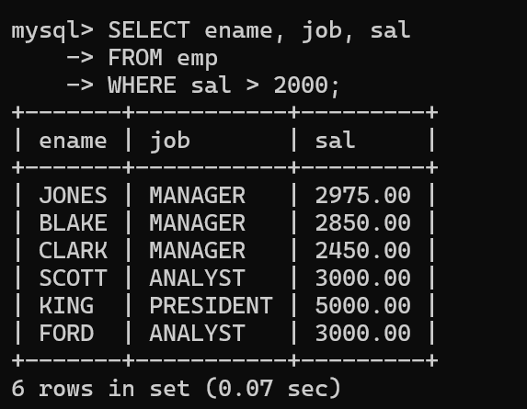CLAUSES:

EXISTS:

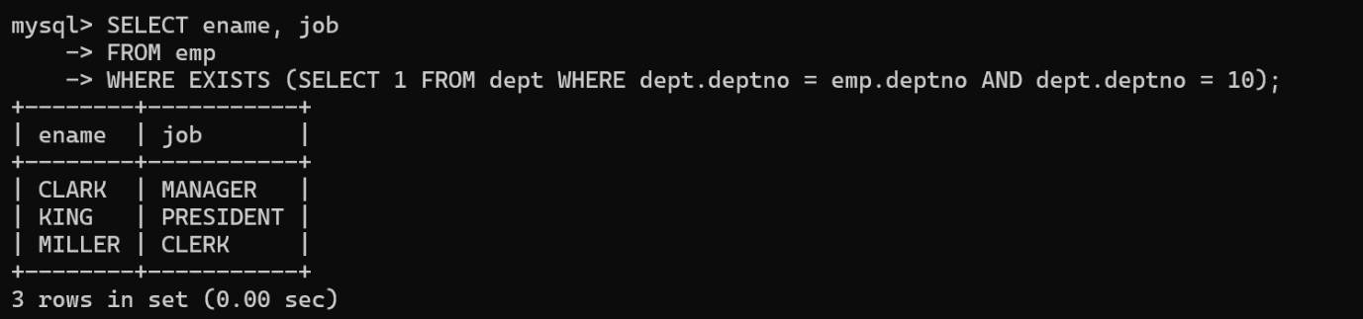

WILCARDS:

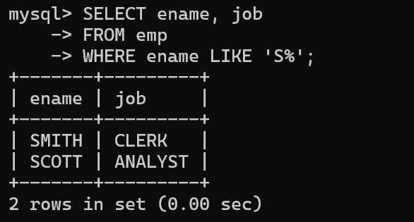

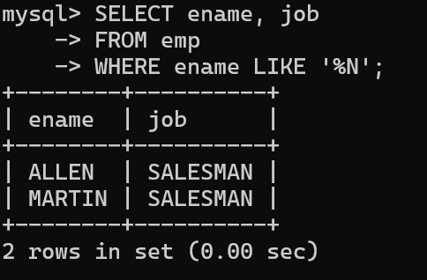

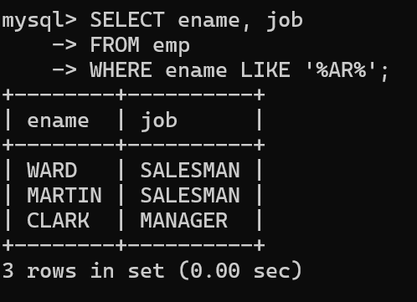

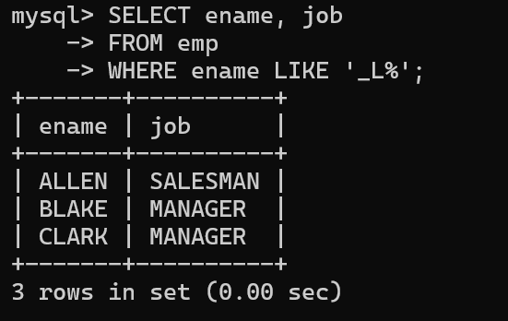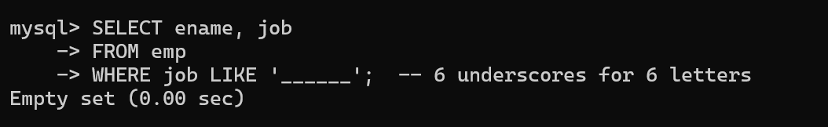

ALTER COMMANDS:

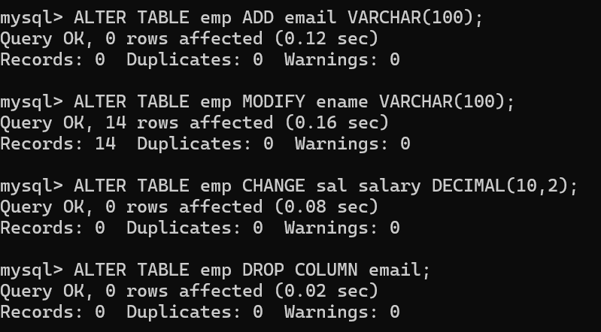

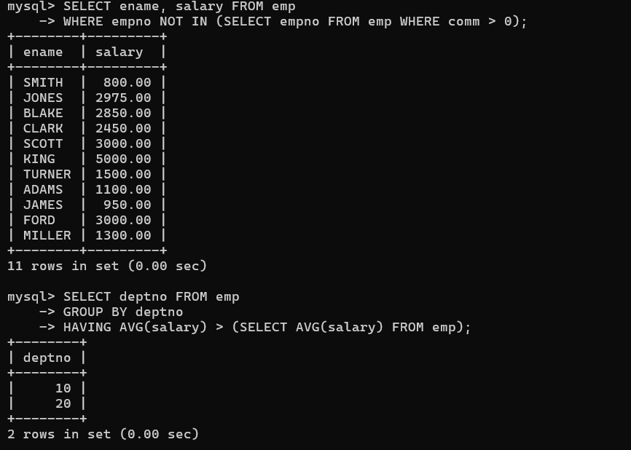SUBQUERIES:

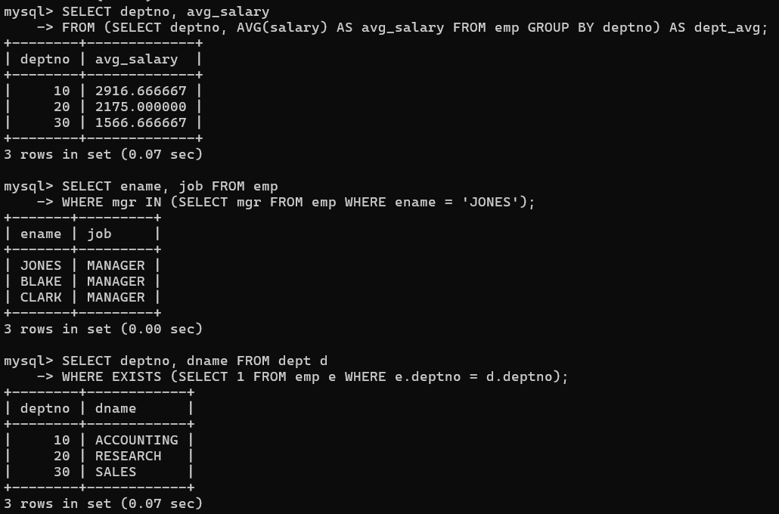

SQL COMMANDS:

1.DDL

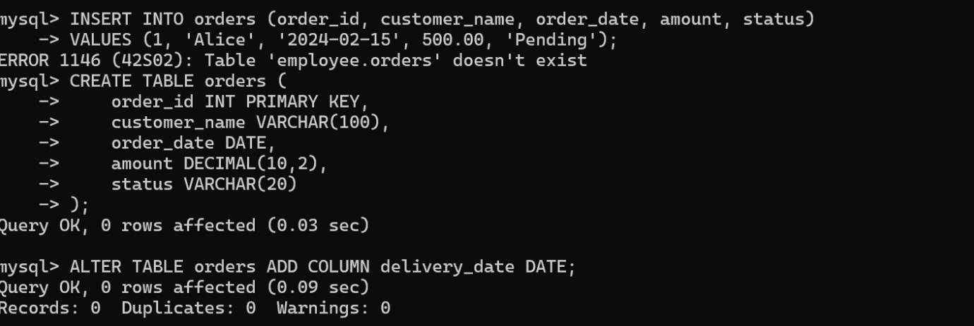

2.DML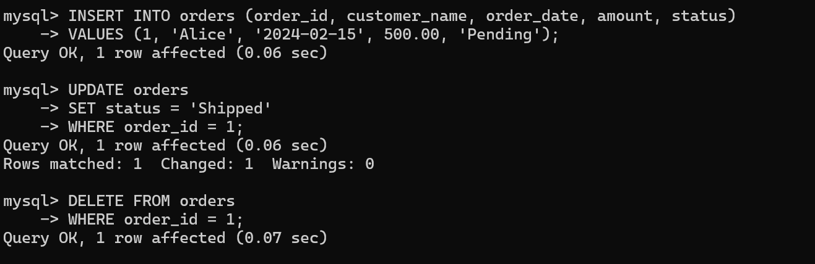

3.DQL

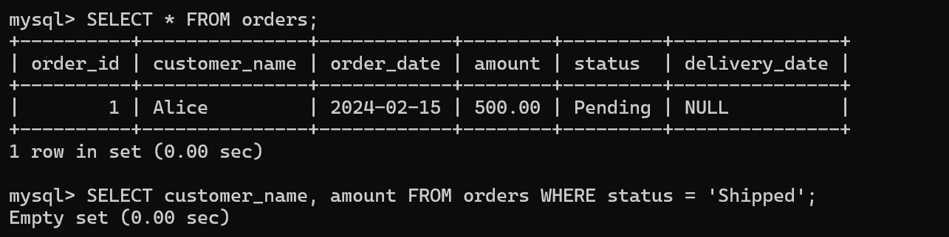

4.TCL

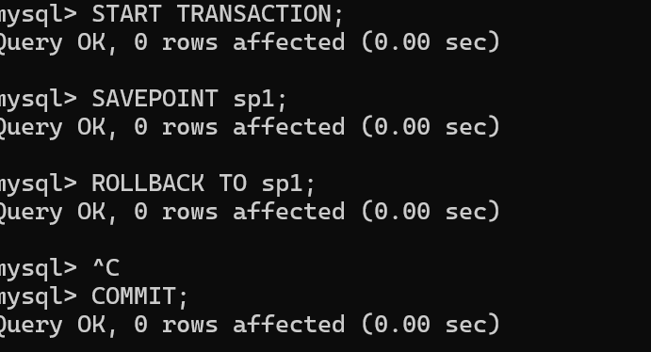

And

SELECT *

FROM Customers

WHERE Country = 'Spain' AND CustomerName LIKE 'G%';

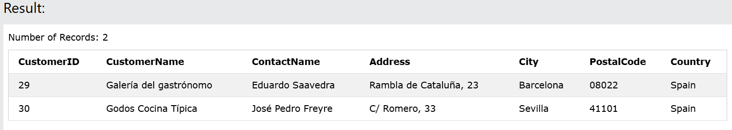

**Distinct**

SELECT DISTINCT Country FROM Customers;

Number of Records: 21

|  |
| --- |
| **Country** |
| Argentina |
| Austria |
| Belgium |
| Brazil |
| Canada |
| Denmark |
| Finland |
| France |
| Germany |
| Ireland |
| Italy |
| Mexico |
| Norway |
| Poland |
| Portugal |
| Spain |
| Sweden |
| Switzerland |
| UK |
| USA |
| Venezuela |

**OR**

SELECT *  
FROM Customers  
WHERE Country = 'Germany' OR Country = 'Spain';

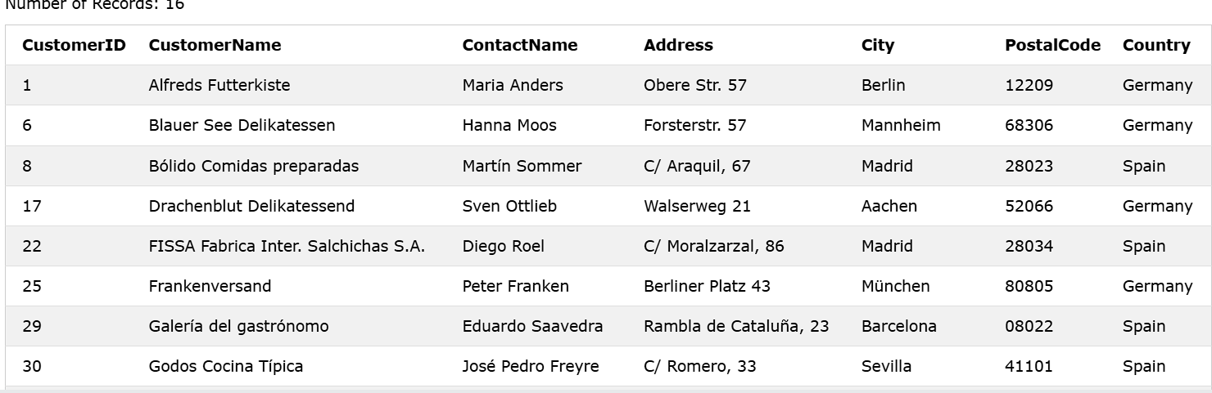

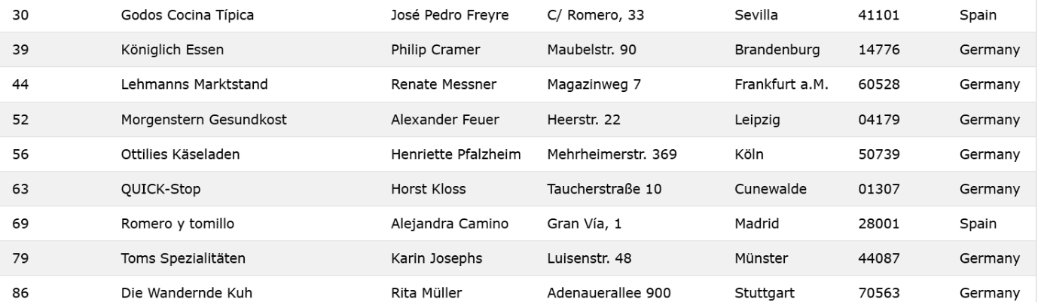

**SELECT TOP**

SELECT TOP 3 * FROM Customers;

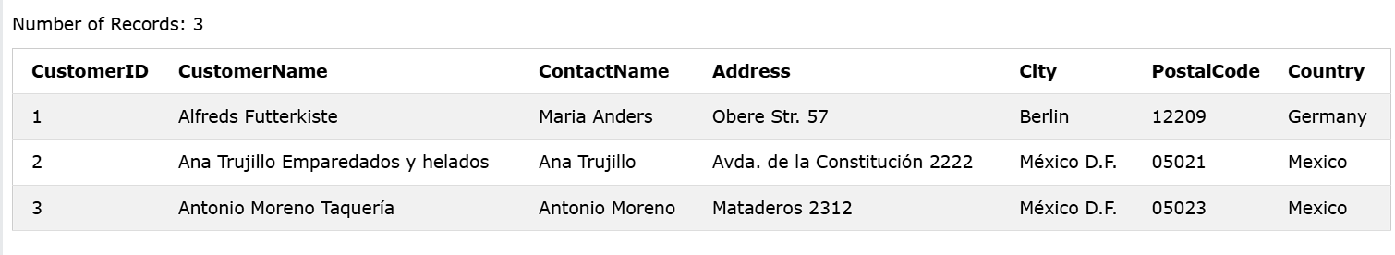

**ALIASES**

SELECT CustomerID AS ID

FROM Customers;

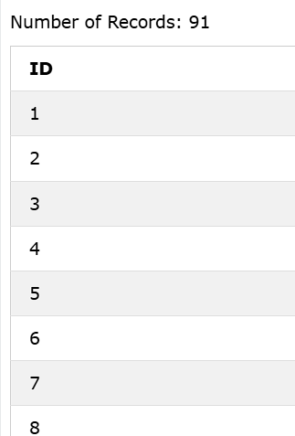

**IN**

SELECT * FROM Customers

WHERE Country IN ('Germany', 'France', 'UK');

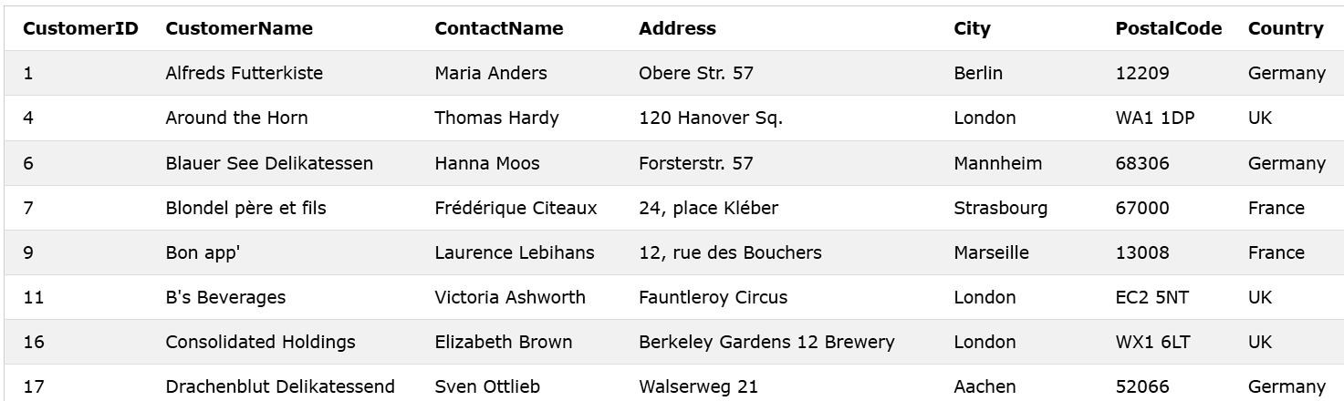

**BETWEEN**

SELECT * FROM Products  
WHERE Price BETWEEN 10 AND 20;

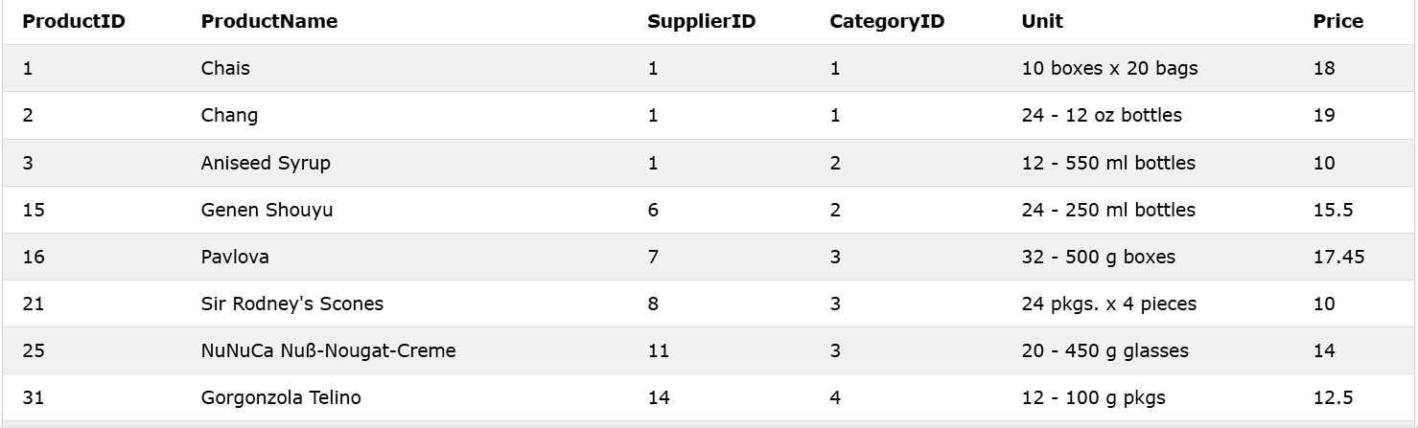

**LEFT JOIN**

SELECT Customers.CustomerName, Orders.OrderID  
FROM Customers  
LEFT JOIN Orders ON Customers.CustomerID = Orders.CustomerID  
ORDER BY Customers.CustomerName;

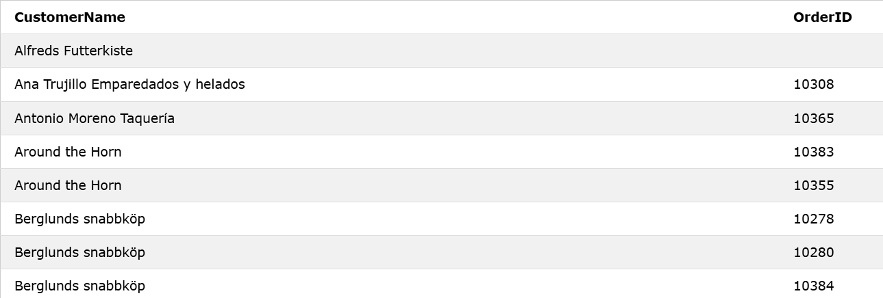

**UNION**

SELECT City FROM Customers  
UNION  
SELECT City FROM Suppliers  
ORDER BY City;

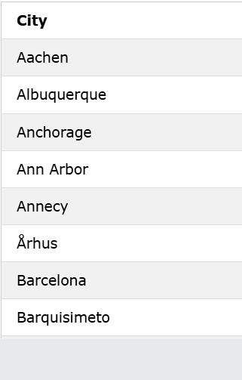

**ANY**

SELECT ProductName  
FROM Products  
WHERE ProductID = ANY  
  (SELECT ProductID  
  FROM OrderDetails  
  WHERE Quantity = 10);

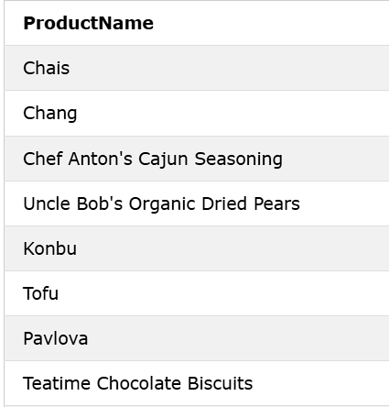

**ALL**

SELECT ALL ProductName  
FROM Products  
WHERE TRUE;

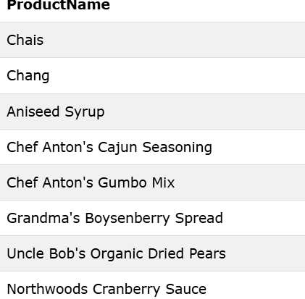

**CONSTRAINTS**

**1.NOT NULL**

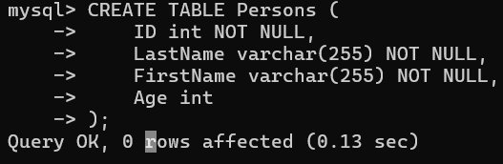

**2.UNIQUE KEY**

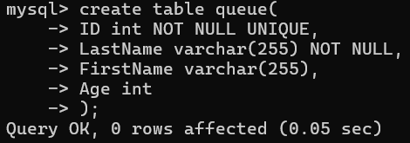

**3.PRIMARY KEY**

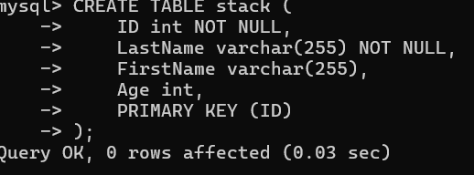

**4.FOREIGN KEY**

**5.CHECK**

